EV BATTERY ANALYTICS PLATFORM
Project Report

Submitted By
Nanditha S Nambiar
B.Tech Production Engineering
National Institute of Technology Calicut

CONTENTS
- Abstract
- Introduction
- Problem Statement
- Objectives
- Datasets
- Technology Stack
- Methodology
- Battery Degradation Analysis
- State of Health (SOH) Analysis
- EV Market Analytics
- Dashboard Development
- Results and Insights
- Conclusion
- Future Scope
- References

1. ABSTRACT
Electric Vehicles (EVs) are becoming increasingly important in the global transportation sector. Battery performance and degradation significantly influence EV reliability, safety, and economic viability. This project presents an integrated EV Battery Analytics Platform developed using Python, SQL, Streamlit, and data visualization techniques.
The platform combines battery degradation analysis using NASA battery datasets and market analysis using a global electric vehicle specifications dataset. The system enables battery health monitoring, state-of-health estimation, capacity degradation tracking, EV market benchmarking, drivetrain analysis, battery capacity comparison, and efficiency evaluation through an interactive dashboard.
The project demonstrates the application of data analytics and visualization techniques for battery health assessment and EV market intelligence.

2. INTRODUCTION
The rapid growth of electric vehicles has increased the importance of battery monitoring and performance analysis. Battery degradation directly affects vehicle range, charging performance, operational safety, and maintenance costs.
Modern EV manufacturers and fleet operators rely heavily on battery analytics to estimate remaining useful life and predict performance deterioration.
Alongside battery health monitoring, understanding EV market trends such as driving range, battery capacity, drivetrain configurations, and efficiency metrics is critical for product development and strategic decision-making.
This project aims to bridge both aspects by developing a comprehensive analytics platform capable of performing battery degradation analysis and EV market intelligence using real-world datasets.

3. PROBLEM STATEMENT
Electric vehicle batteries experience gradual degradation due to repeated charge-discharge cycles and environmental conditions.
Key challenges include:
- Tracking battery degradation over time.
- Estimating battery State of Health (SOH).
- Identifying healthy and degraded batteries.
- Understanding temperature effects on battery performance.
- Comparing EV models based on range and battery specifications.
- Analyzing drivetrain and vehicle segment distributions.
A unified analytical framework is required to visualize and interpret these datasets effectively.

4. OBJECTIVES
The primary objectives of this project are:
- Analyze battery degradation using NASA battery datasets.
- Calculate and visualize battery State of Health (SOH).
- Identify the healthiest and most degraded batteries.
- Study the influence of ambient temperature on battery performance.
- Analyze EV specifications from a global EV dataset.
- Compare vehicle range, battery capacity, and efficiency.
- Examine drivetrain distributions and market segmentation.
- Develop an interactive Streamlit dashboard for visualization and decision support.

5. DATASETS
5.1 NASA Battery Dataset
The NASA Battery Dataset contains experimental battery charge-discharge cycle data collected under controlled operating conditions.
Key Attributes:
- Battery ID
- Ambient Temperature
- Test ID
- Capacity (Ah)
Applications:
- Battery degradation tracking
- SOH estimation
- Performance monitoring

5.2 Electric Vehicle Specifications Dataset
A global EV specifications dataset was used to analyze market trends and vehicle performance.
Key Attributes:
- Brand
- Model
- Range (km)
- Battery Capacity (kWh)
- Drivetrain
- Segment
- Efficiency
Applications:
- EV market analysis
- Brand comparison
- Efficiency benchmarking
- Drivetrain analysis

6. TECHNOLOGY STACK
Programming Language:
- Python
Libraries:
- Pandas
- NumPy
- Plotly Express
- Matplotlib
- Streamlit
Database Querying:
- SQL

Development Environment:
- Visual Studio Code
- Jupyter Notebook
Version Control:
- Git
- GitHub

7. METHODOLOGY
The project workflow consists of four major stages:
Stage 1: Data Collection
- NASA battery degradation dataset
- EV specifications dataset
Stage 2: Data Cleaning
Battery Dataset:
- Removal of invalid capacity values
- Filtering zero-capacity records
- Sorting battery cycles
EV Dataset:
- Handling missing values
- Standardization of columns

Stage 3: Data Analysis
Battery Analytics:
- Capacity degradation
- SOH computation
- Temperature analysis
EV Analytics:
- Brand comparison
- Battery capacity analysis
- Efficiency analysis
- Segment analysis
Stage 4: Dashboard Development
An interactive Streamlit dashboard was developed to visualize analytical results.

8. BATTERY DEGRADATION ANALYSIS
Battery degradation was analyzed using capacity measurements collected across multiple discharge cycles.
For each battery:
Initial Capacity = Maximum observed capacity
Final Capacity = Capacity at final cycle
The degradation trend was visualized through line plots showing capacity reduction over operational cycles.
Observations:
- Capacity decreases progressively with cycling.
- Different batteries exhibit different degradation rates.
- Certain batteries retain performance significantly better than others.
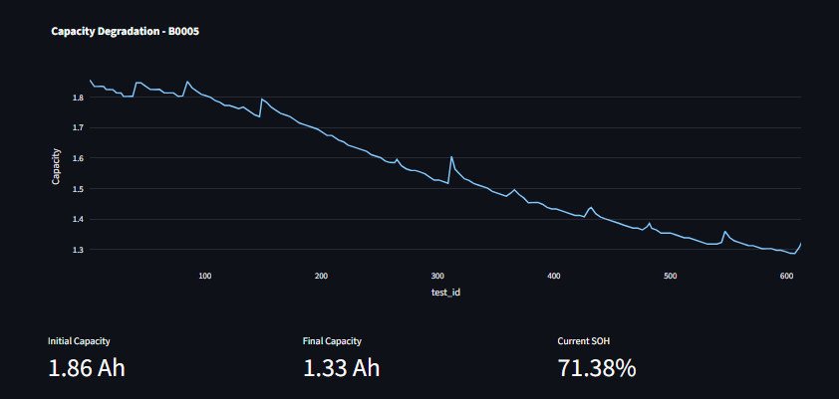
Fig1. Capacity degradation curve

9. STATE OF HEALTH (SOH) ANALYSIS
Battery State of Health was calculated using:
SOH (%) = (Final Capacity / Initial Capacity) × 100
The SOH metric provides an estimate of remaining battery health relative to its initial condition.
Key Findings:
Average SOH = 72.17%
Best Battery:
- B0026
- SOH = 97.37%
Most Degraded Battery:
- B0050
- SOH = 10.53%
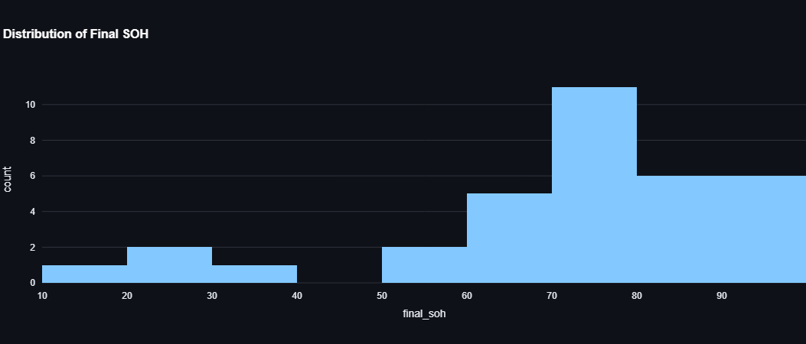
Fig 2: SOH Distribution

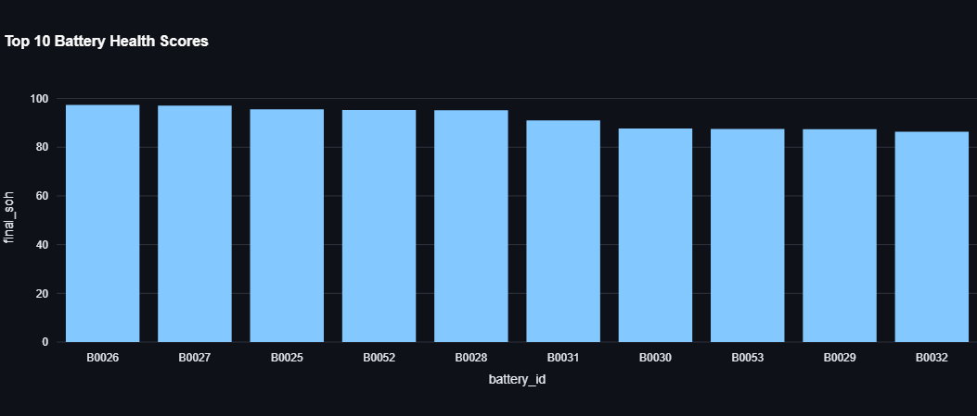
Fig 3: Top Healthy Batteries

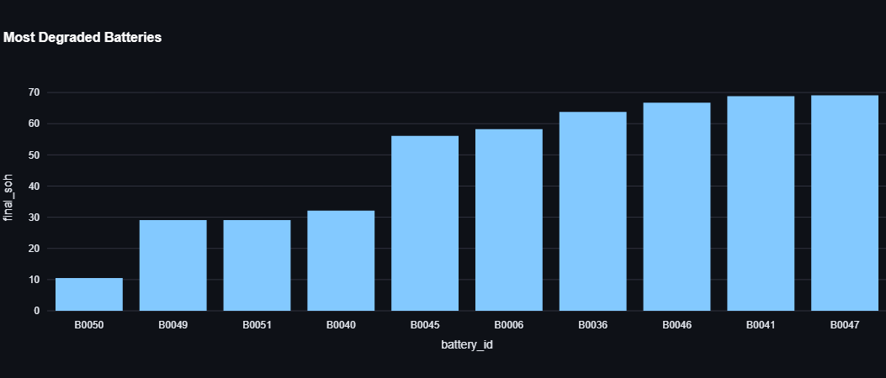
Fig 4: Most Degraded Batteries

10. EV MARKET ANALYTICS
The EV dataset was analyzed to study market characteristics and vehicle performance.
Range Analysis
Brands with highest average range:
- Lucid
- Porsche
- Tesla
- Lotus
Battery Capacity Analysis
Brands with highest average battery capacity:
- Lotus
- Rolls-Royce
- Cadillac
- Voyah
Efficiency Analysis
Most efficient brands included:
- Tesla
- Renault
- Mazda
- DS

Segment Analysis
Most common vehicle segment:
- JC-Medium
Drivetrain Analysis
Distribution:
- AWD: 40%
- FWD: 32.6%
- RWD: 27.4%

- 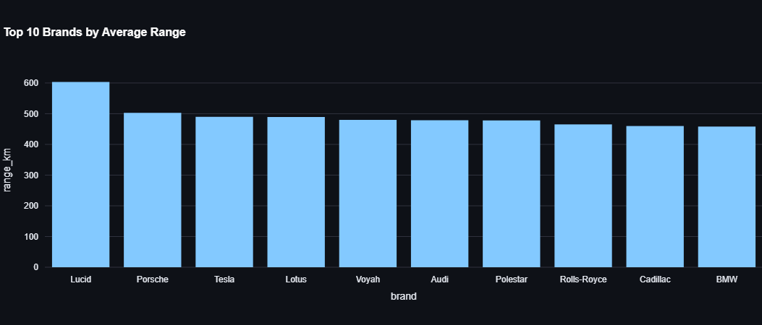
Fig 5: Range Analysis

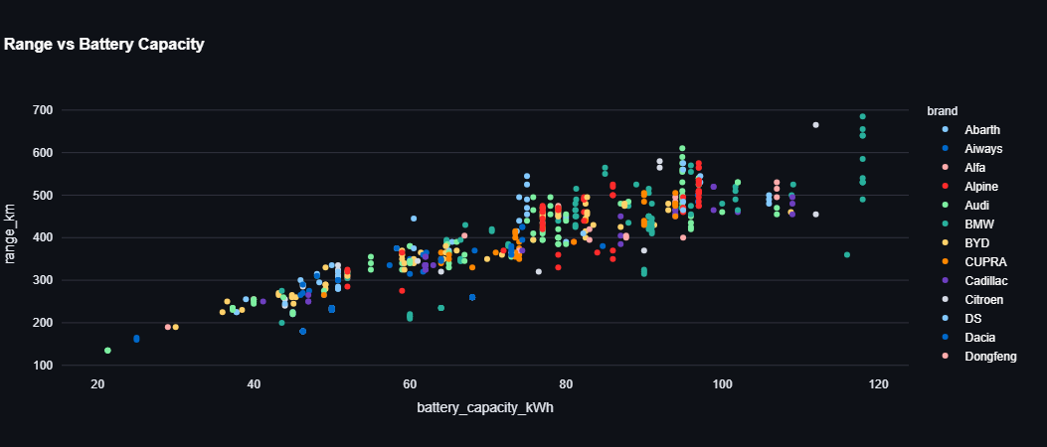
Fig 6: Battery Capacity Analysis
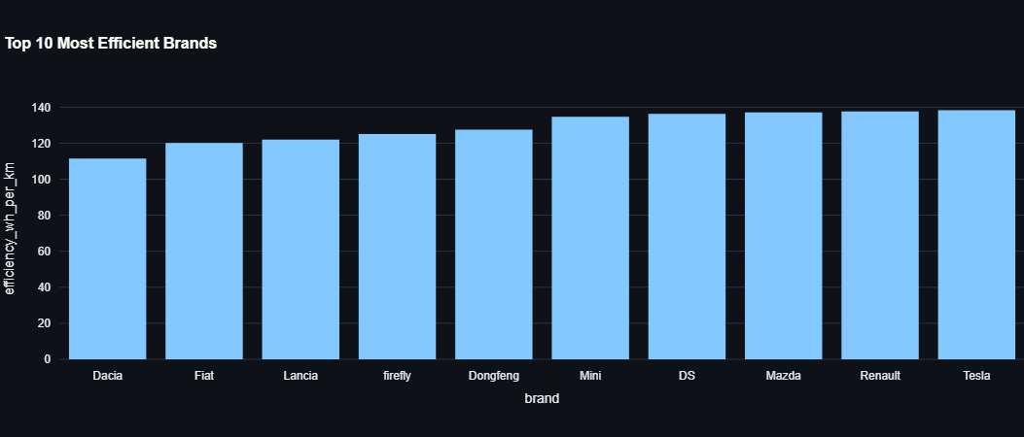
Fig 7: Efficiency Analysis
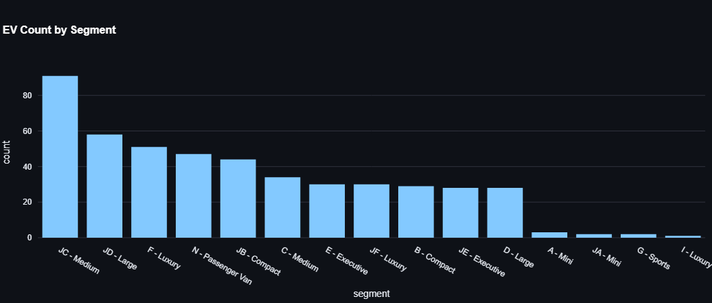
Fig 8: Segment Distribution
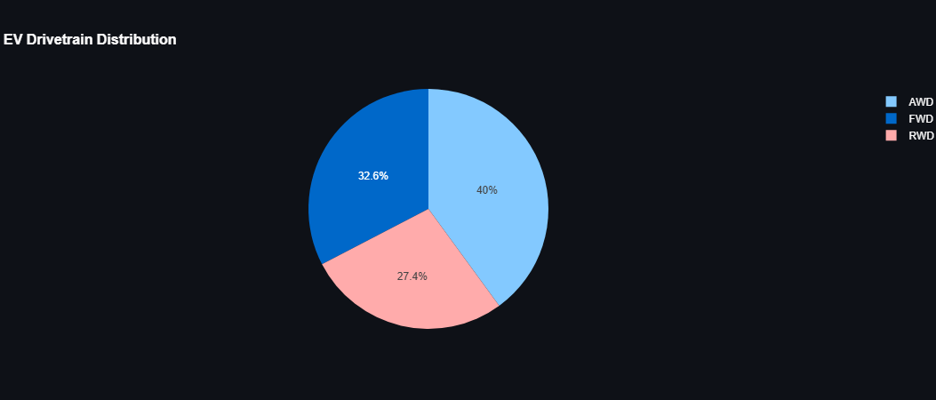
Fig 9: Drivetrain Distribution

11. DASHBOARD DEVELOPMENT
An interactive Streamlit dashboard was developed with two analytical modules.
Battery Analytics Module
Features:
- Battery Health Overview
- SOH Distribution
- Battery Status Indicator
- Capacity Degradation Visualization
- Temperature Analysis
EV Market Analytics Module
Features:
- Market KPIs
- Range Analysis
- Efficiency Analysis
- Segment Analysis
- Drivetrain Distribution
- Battery Capacity Comparison
- 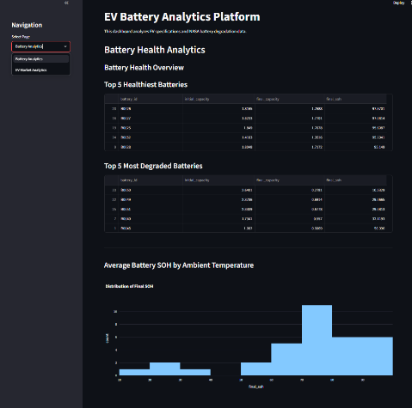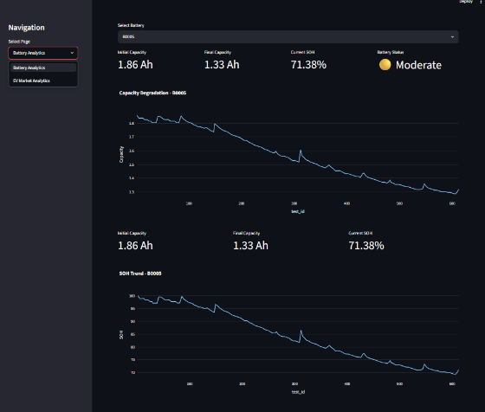
- 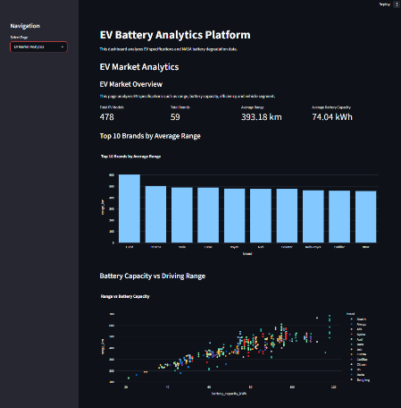
Figure 10: Dashboard Homepage

12. RESULTS AND INSIGHTS
Battery Analytics:
- Average battery SOH is 72.17%.
- Battery B0026 showed highest retained health.
- Battery B0050 exhibited severe degradation.
EV Market Analytics:
- Lucid leads in average driving range.
- Lotus leads in average battery capacity.
- AWD is the most common drivetrain configuration.
- Medium-size vehicles dominate the EV market dataset.

13. CONCLUSION
An integrated EV Battery Analytics Platform was successfully developed using Python, SQL, and Streamlit.
The platform effectively performs battery degradation analysis and EV market intelligence through interactive visualizations and analytical dashboards. The system enables rapid assessment of battery health, comparison of vehicle specifications, and identification of market trends.
The project demonstrates practical applications of data analytics, visualization, and dashboard development within the electric vehicle domain.

14. FUTURE SCOPE
Potential future enhancements include:
- Machine Learning based SOH prediction.
- Remaining Useful Life (RUL) estimation.
- Battery fault detection.
- Real-time IoT battery monitoring.
- Cloud deployment of dashboard.
- Integration with Battery Management Systems (BMS).
- Predictive maintenance analytics.

15. REFERENCES
[1] NASA Battery Dataset.
[2] Streamlit Documentation.
[3] Pandas Documentation.
[4] Plotly Documentation.
[5] Electric Vehicle Specifications Dataset.
[6] Python Software Foundation.

